EXPERIMENT-8
Name: Rohith Nikethan P Roll No: 240701437

To design and represent the user flow application using Balsamiq, focusing on lowfidelity prototypes that visualize the navigation and interaction sequence in a single screen storyboard format.
Tools & Software:
- Balsamiq– for creating low-fidelity wireframes and storyboards.
- HerbaFit App Concept – herbal supplements shopping application with features like product browsing, rewards, coupon codes, and order tracking.

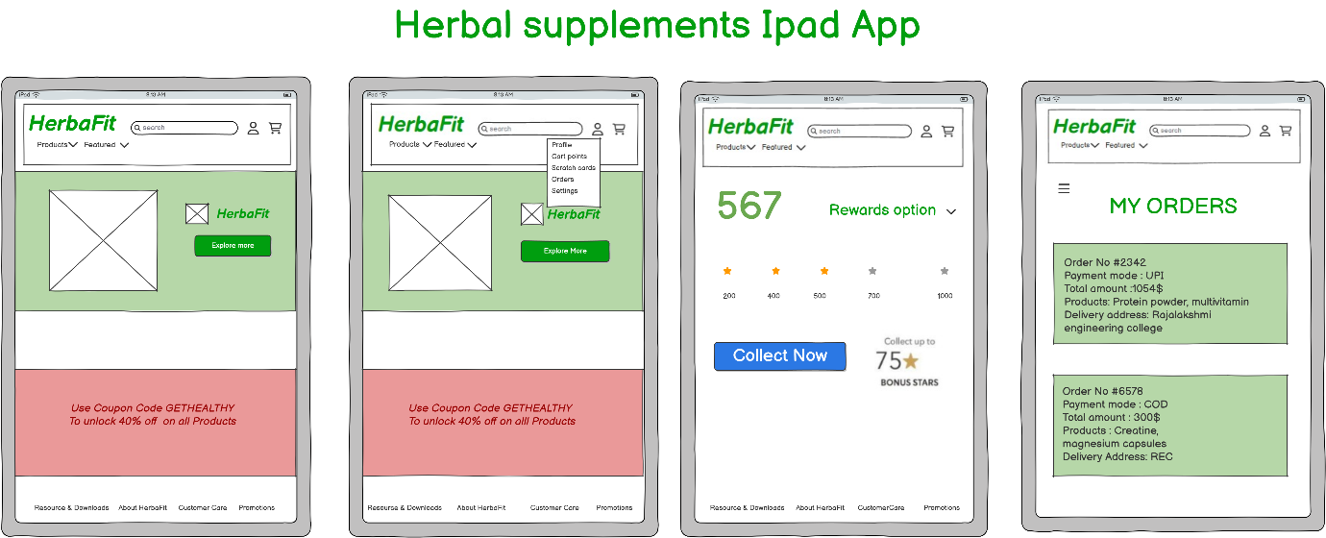

The storyboard captures the following application flow:
- Home Screen
  - Logo, search bar, navigation tabs (Products, Featured).
  - Promotional banner with coupon code.
  - Call to action button: Explore More.
- User Menu
  - Dropdown options: Profile, Cart Points, Scratch Cards, Orders, Settings.
- Rewards Page
  - Display of earned stars
  - Bonus collection option with Collect Now button.
- Orders Page
  - List of past orders with details:
    - Order number, payment mode, total amount.
    - Products purchased.
    - Delivery address.

